Name: ______________________
Class: _______________________
Part one: Reading comprehension
Read the text and answer the following questions:
اقرأ القطعة التالية واجب عن الاسئلة التي تليها
What do you know about Elephants?
By Frank Smith
Elephants are very interesting animals. They are one of the biggest animals in the world. They have two big teeth called tusks. The tusks help them dig for water, carry heavy things, and fight with other animals. Elephants have a long nose called trunk. Elephants can do many things with their trunks: they smell with them, make noises with them, and use them to take a shower.
Most elephants live in Africa and Asia. They eat a lot, but only plants and leaves. Elephants have a good memory when they find water will remember the place for a very long time.
Elephants have feelings too. They are afraid when they are in danger, sad when other elephants are hurt and happy when they meet friends and family.
Elephants have big families/ they all live together and help each other. When elephants need help they make special sounds. These sounds are special because people cannot hear them.

Questions:
1-who is the writer of the text?

_____________________________.

2-where do most elephants live?

______________________________.

3-choose the right answer:
Elephants can remember places.
This can help the ____.
- Find water.
- Hear people.
- Make sounds.
- Carry things.

**************
4- Elephants have feelings
Give examples:
- ____________________.

- ____________________.
5. put Yes or No next to each sentence according to the text:

a. Elephants eat meat _______.
b. People can hear the elephants' special sounds _________.
c. Elephants live with their families _________.

6. Which question has an answer in the text?
- Why do elephants fight?
- When do elephants eat and drink?
- How do elephants remember sounds?
- What do elephants do with their trunks?

****************************
3- Write the correct pronoun اكتب الضمير الملائم
- a cat ________
- Ahmad _______
- Marwa _______
- My mother and father _________
- You and Amal ____________
- My brother and I ___________

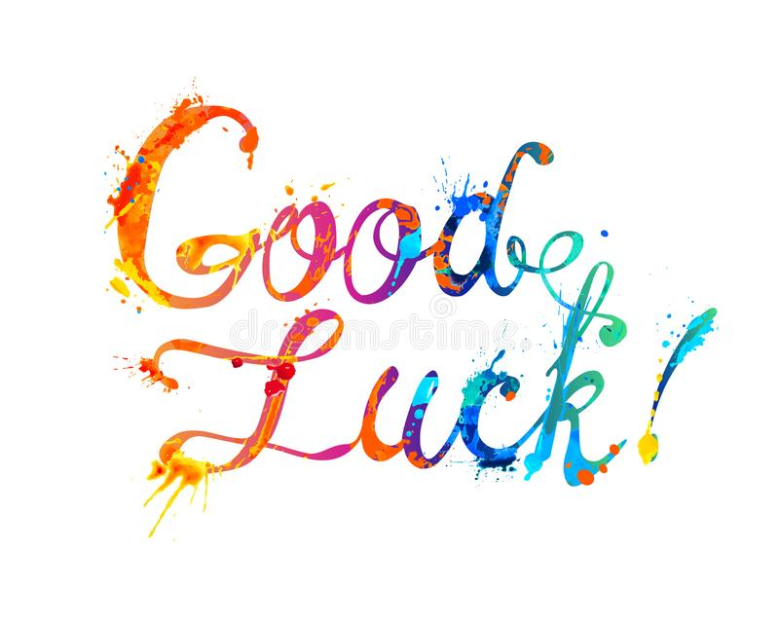
Good Luck

