
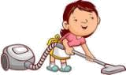
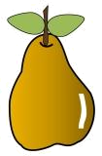
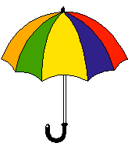
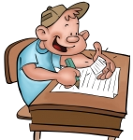
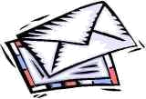
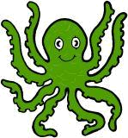
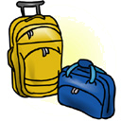
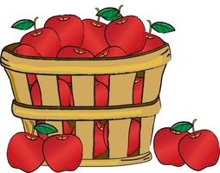
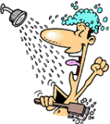
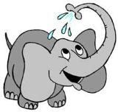
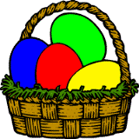
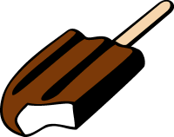
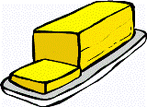
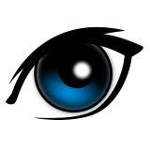
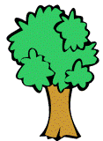
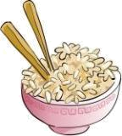
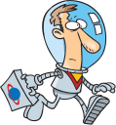
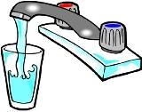
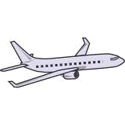
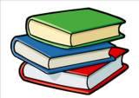
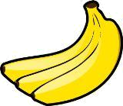
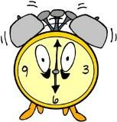
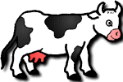
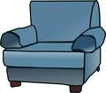
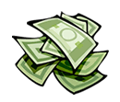
Choose the correct answer.
a) a exam
b) an exam
c) some exam

a) a water
b) an water
c) some water

a) a bananas
b) an bananas
c) some bananas

a) a shower
b) an shower
c) some shower

a) a rice
b) an rice
c) some rice

a) a butter
b) an butter
c) some butter

a) a cow
b) an cow
c) some cow

a) a octopus
b) an octopus
c) some octopus

a) a eggs
b) an eggs
c) some eggs

a) a plane
b) an plane
c) some plane

a) a pear
b) an pear
c) some pear
a) a eye
b) an eye
c) some eye

a) a money
b) an money
c) some money

a) a elephant
b) an elephant
c) some elephant

a) a luggage
b) an luggage
c) some luggage

a) a books
b) an books
c) some books

a) a tree
b) an tree
c) some tree

a) a housework
b) an housework
c) some housework
a) a hour
b) an hour
c) some hour

a) a umbrella
b) an umbrella
c) some umbrella

a) a astronaut
b) an astronaut
c) some astronaut

a) a ice cream
b) an ice cream
c) some ice cream

a) a apples
b) an apples
c) some apples

a) a armchair
b) an armchair
c) some armchair

a) a letters
b) an letters
c) some letters

Choose the correct answer.
a) a exam
b) an exam
c) some exam

a) a water
b) an water
c) some water

a) a bananas
b) an bananas
c) some bananas

a) a shower
b) an shower
c) some shower

a) a rice
b) an rice
c) some rice

a) a butter
b) an butter
c) some butter

a) a cow
b) an cow
c) some cow

a) a octopus
b) an octopus
c) some octopus

a) a eggs
b) an eggs
c) some eggs

a) a plane
b) an plane
c) some plane

a) a pear
b) an pear
c) some pear
a) a eye
b) an eye
c) some eye

a) a money
b) an money
c) some money

a) a elephant
b) an elephant
c) some elephant

a) a luggage
b) an luggage
c) some luggage

a) a books
b) an books
c) some books

a) a tree
b) an tree
c) some tree

a) a housework
b) an housework
c) some housework
a) a hour
b) an hour
c) some hour

a) a umbrella
b) an umbrella
c) some umbrella

a) a astronaut
b) an astronaut
c) some astronaut

a) a ice cream
b) an ice cream
c) some ice cream

a) a apples
b) an apples
c) some apples

a) a armchair
b) an armchair
c) some armchair

a) a letters
b) an letters
c) some letters

Choose the correct answer.
a) a exam
b) an exam
c) some exam

a) a water
b) an water
c) some water

a) a bananas
b) an bananas
c) some bananas

a) a shower
b) an shower
c) some shower

a) a rice
b) an rice
c) some rice

a) a butter
b) an butter
c) some butter

a) a cow
b) an cow
c) some cow

a) a octopus
b) an octopus
c) some octopus

a) a eggs
b) an eggs
c) some eggs

a) a plane
b) an plane
c) some plane

a) a pear
b) an pear
c) some pear
a) a eye
b) an eye
c) some eye

a) a money
b) an money
c) some money

a) a elephant
b) an elephant
c) some elephant

a) a luggage
b) an luggage
c) some luggage

a) a books
b) an books
c) some books

a) a tree
b) an tree
c) some tree

a) a housework
b) an housework
c) some housework
a) a hour
b) an hour
c) some hour

a) a umbrella
b) an umbrella
c) some umbrella

a) a astronaut
b) an astronaut
c) some astronaut

a) a ice cream
b) an ice cream
c) some ice cream

a) a apples
b) an apples
c) some apples

a) a armchair
b) an armchair
c) some armchair

a) a letters
b) an letters
c) some letters

