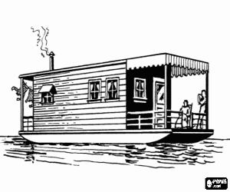
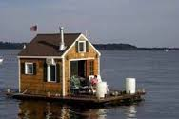
David and his family live on a boat in France. There is a cabin (בקתה) on the boat. The cabin is just like a HOUSE. It has windows, a kitchen, a bathroom and two small bedrooms. The Family eats and sleeps there. David and his family like to sit outside in the sun. David goes to school away from HOME but he is always happy to come HOME to his family.

Sam lives in Japan. His father made their HOUSE from wood (עץ) because there are many tall trees in Japan. Many People don’t wear shoes in Japanese houses. There are rugs on the floor and Sam and his family sit on them in the day and sleep on them at night. Sam has a lovely garden around his HOUSE. Japanese people love gardens and have beautiful trees and flowers in them.

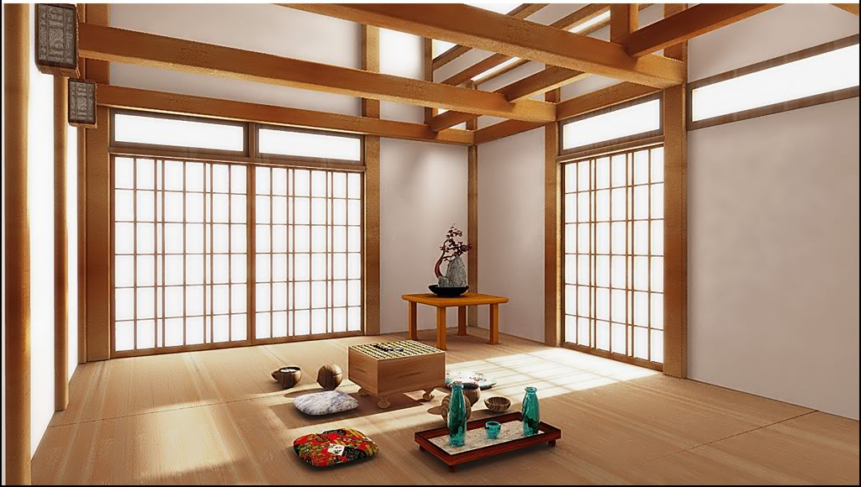
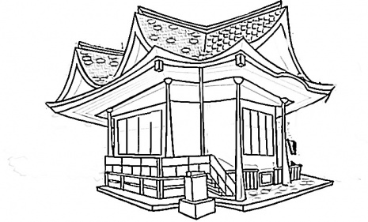
Different houses
Name: ______________ Class: ___________
أي الجمل التالية تتحدث عن بيت سام واي جمل تتحدث عن بيت دافيد؟؟
 |  | Sam | David
1. | The house is made from wood.
2. | There is a cabin on the boat.
3. | There is a garden around the house.
4. | There are rugs on the floor.
5. | The family likes to sit in the sun.

ב. התאימו בין טור (A) לטור (B): (%15)
 | A |  | B
1 | We sleep there. | a | bedroom
2 | Mom makes food there. | b | bathroom
3 | We watch T.V there. | c | dining room
4 | We eat there. | d | living room
5 | We have a *shower there. | e | kitchen
* shower: מקלחת

اكتب الكلمة الناقصة حسب النص :
1. David's cabin is like a _____________.
2. David's family likes to sit ______________.
3. David is always ___________ to come home.
4. There are many tall ____________ in Japan.
5. People in Japan don't wear _____________ in houses.

Write yes or no اكتب نعم او لا
1. David lives on a boat in England. ________
2. There is one bedroom in David's house. ______
3. Japanese people love gardens. _______
4. People in Japan sit and sleep on the rugs. _______
5. David's family eats and sleeps in the house. _______

