**Name: __________ class:_______________.**

**Read the text and answer the questions اقرا النص ثم اجب عن الأسئلة**



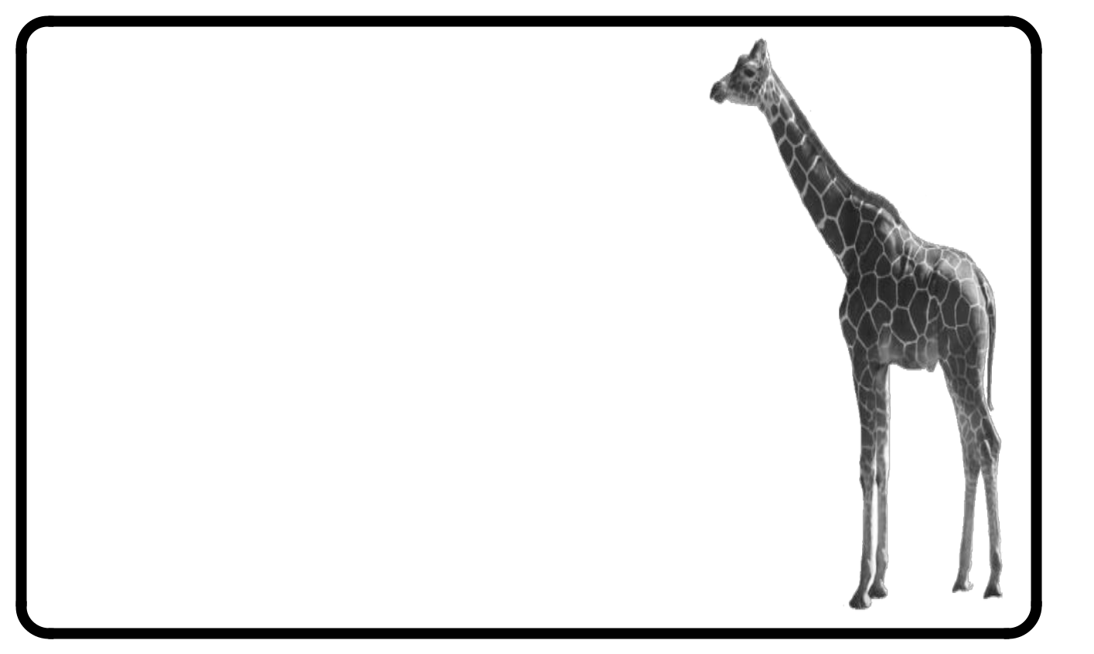

Giraffes are incredible animals. Giraffes live in the Savannah, in Africa. Giraffes are vegetarian, they eat mostly leaves that grow on trees, that’s why they have got such long necks. Giraffes are yellow, with small brown spots. Giraffes have got a small head, with small eyes, small ears and a big nose and mouth. They have also got two small horns. They have got a big body and a long tail. They have got four long legs. Giraffes can run and jump, they can also swim but they can’t climb trees or fly. Do you like giraffes?

1. Where do Giraffes live? ___________________________
   1. What do Giraffes eat? __________________________
   2. Why do they have long necks? _____________________
   3. What color are they? _______________________
   4. Have they got sports? ________________________
   5. What can they do? __________________________

7. What can’t they do? ______________________________

**There is / there are**

**COMPLETE THE SENTENCE WITH THE CORRECT FORM:**

1. There _____________ many animals in the zoo.
2. There _____________ a snake in the window.
3. There _____________ a zebra in the grass.
4. There _____________ lions in the zoo, too.
5. There _____________ many baby lions near their parents.
6. There _____________ many monkeys in the trees.
7. There _____________ an elephant in the zoo.
8. There _____________ some water in the lake near the elephants.
9. There _____________ birds in the zoo.
10. There _____________ many people visiting the animals today.
11. There _____________ many children, too.
12. There _____________ a gorilla in the tree.
13. There _____________ some grass under the tree.
14. There _____________ bananas in the tree with the gorilla.
15. There _____________ many birds near the gorilla.
16. There _____________ a rock near the tree.
17. There _____________ many sharks in the aquarium.
18. There _____________ an eel in the aquarium, too.
19. There ______________ lots of water for the fish.

