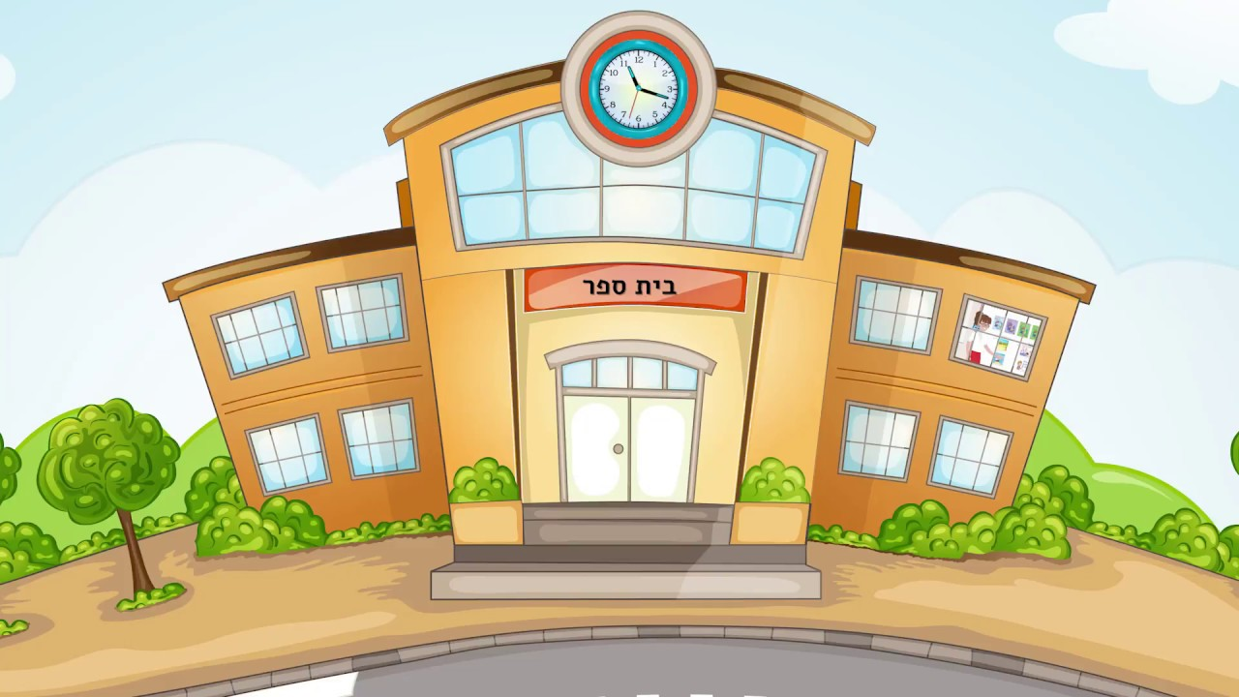









[](https://www.google.co.il/url?sa=i&rct=j&q=&esrc=s&source=images&cd=&ved=2ahUKEwihk-DyzYXnAhURy4UKHQf6A-IQjRx6BAgBEAQ&url=https%3A%2F%2Fsimania.co.il%2Fgroup.php%3FgroupId%3D60&psig=AOvVaw2WXUh7oF7uupcT-_JFHJmA&ust=1579177798504704)

[](https://www.google.co.il/url?sa=i&rct=j&q=&esrc=s&source=images&cd=&ved=2ahUKEwiH1-uVzoXnAhVMrxoKHXT-CZkQjRx6BAgBEAQ&url=https%3A%2F%2Fpublicdomainvectors.org%2Fhe%2F%25D7%25A7%25D7%259C%25D7%2599%25D7%25A4%25D7%25A8%25D7%2598%2520%25D7%2597%25D7%2599%25D7%25A0%25D7%259D%2F%25D7%259E%25D7%2597%25D7%2591%25D7%25A8%25D7%25AA-%25D7%25A6%25D7%2599%25D7%2595%25D7%25A8-%25D7%2595%25D7%25A7%25D7%2598%25D7%2595%25D7%25A8%25D7%2599%2F9113.html&psig=AOvVaw0CrxXNj7XnodVJw_RwQwwb&ust=1579177875261465)