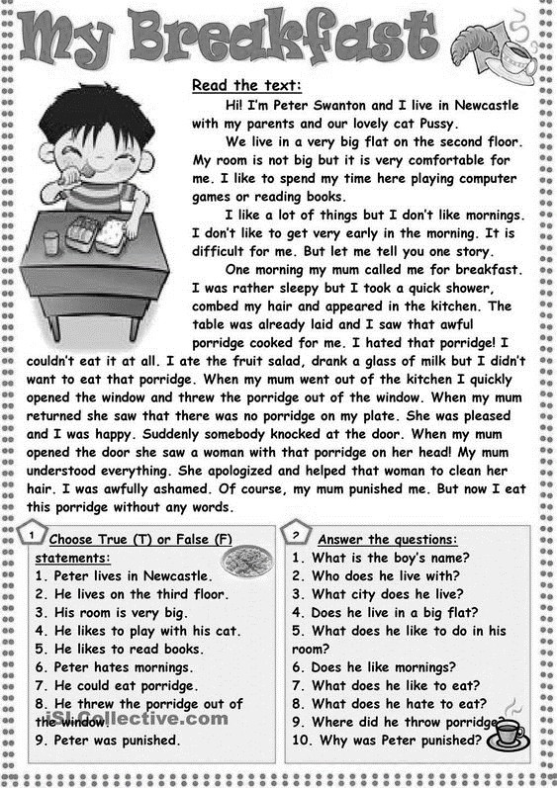

Complete with the correct form of the given verb. حول الفعل الى الزمن الماضي

1. You the plants (water).
2. We a twin room in the hotel (book).
3. They Mary and Rachel to their party (invite).
4. I in Portugal (live).
5. She as a teacher (work).
6. I to the doctor’s advice (listen).
7. You him not to go there (advise).
8. They at the tourists (shout).
9. I late (arrive).
10. Your mother your grandmother (call).
11. They nice (look).
12. It heavily (rain).
13. The boy for help (cry).
14. You and I new clothes on (try).
15. They the house white (paint).
16. He her pardon (beg).
17. These leaves yellow (turn).
18. You and Jane to school (walk).
19. They hard (study).
20. You chess with your friend (play).

