Name: _______________________

First Airplane Trip

Jake is going on a trip. He and

Mom take a taxi to the airport.

“It’s my first plane trip,” he tells the

taxi driver.

“That’s great!” the taxi driver says.

Jake rolls his suitcase onto the

plane.

“It’s my first plane trip,” he tells the pilot.

“Welcome aboard,” the pilot says.

Jake finds his seat and buckles his seatbelt. The plane’s engines

rumble and roar. Jake opens his backpack and pulls out Panda.

“It’s my first plane trip,” he whispers. He holds Panda’s paw.

The plane moves faster and faster. Then—

*Whoosh*

!

On the

ground, cars and houses look like toys.

Jake smiles. “Guess what, Panda?” he says. “Flying is fun!”

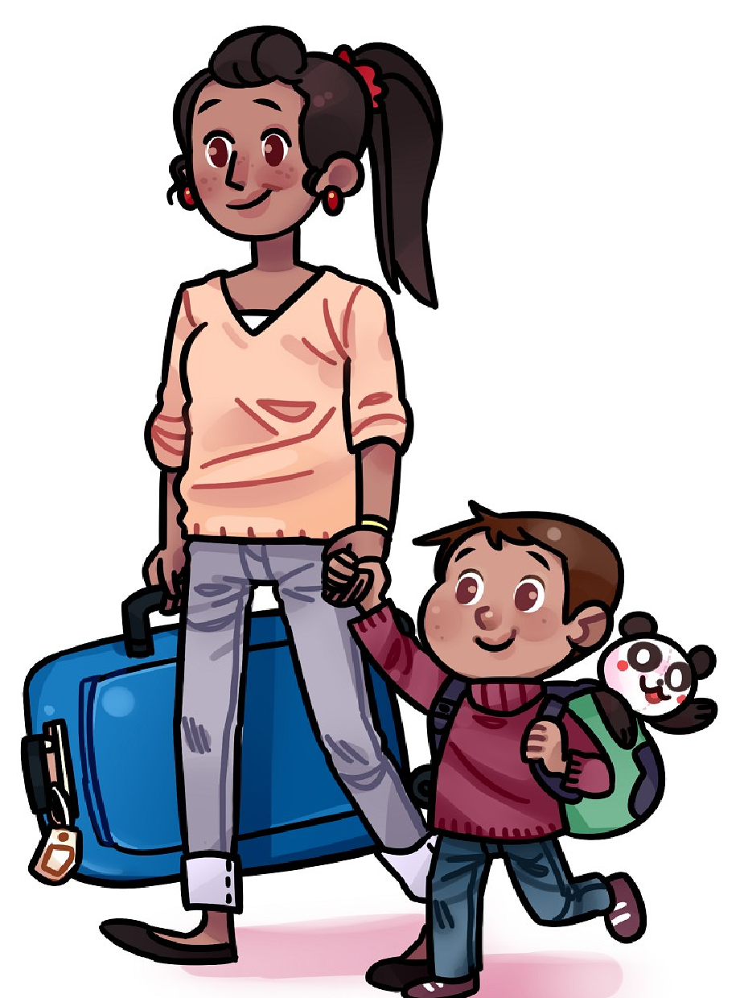

Name: _______________________

|  |  |
| --- | --- |
|  | First Plane Trip  **by Sara Matson** |
| **1.** | How do Jake and his mom travel to the airport? **a.** in a plane **b.** in their car  **c.**  in a taxi **d.** in a bus |
| **2.** | What does a pilot do?  ___________________________________________________________________________ |
| **3.** | What does the pilot say to Jake?  ___________________________________________________________________________ |
| **4.** | Who is Panda?  **a.** Jake's brother **b.** a large animal  **c.** Jake's pet **d.** a stuffed animal |
| **5.** | What does Jake whisper to Panda?  ___________________________________________________________________________ |
| **6.** | Read this sentence from the story:  *On the ground, the cars and houses look like toys.*  What does this mean?   1. The cars and houses looked very big. 2. The cars and houses looked very small. 3. The cars and houses did not move. 4. Jake could not see the cars and houses. |