[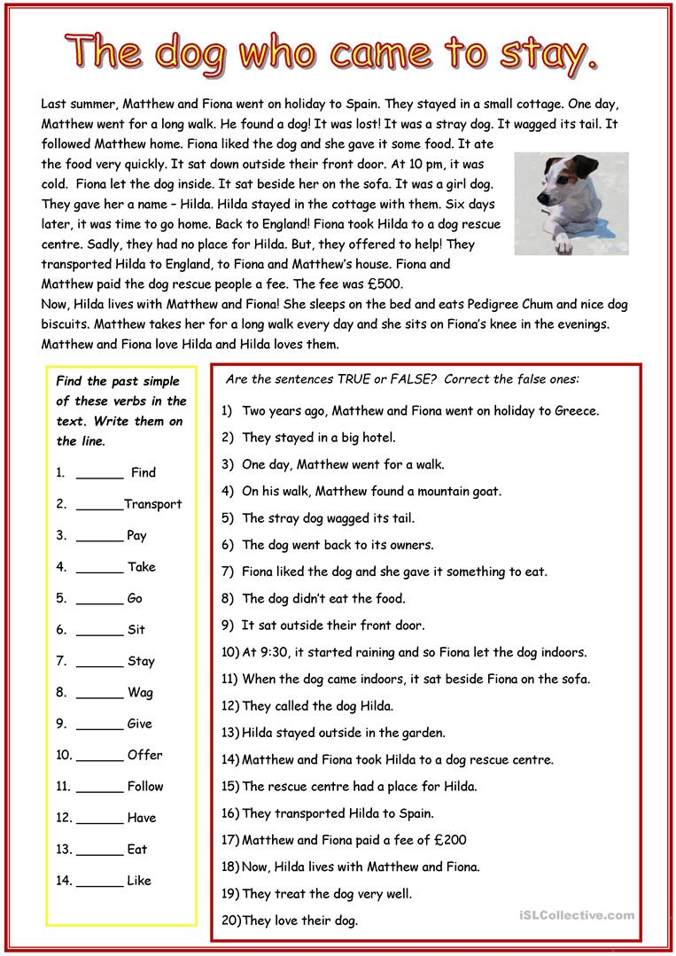](https://www.google.com/url?sa=i&url=https://en.islcollective.com/english-esl-worksheets/grammar/past-simple-tense/reading-comprehension/114113&psig=AOvVaw2nDesCRwIDrMKN6xBRyHFk&ust=1587713290344000&source=images&cd=vfe&ved=0CAIQjRxqFwoTCPCoi4mD_ugCFQAAAAAdAAAAABA6)

**writing**

