Good morning,

How are you today? I hope you are well.

Our lesson today will be about singular\ plural.

درسنا اليوم عن المفرد - جمع

--------------------------------------------

Last time I sent you all the rules, I will assume that you read it and understand it well.

today we will learn about the irregular nouns.

اليوم سنتعلم عن الاسماء الشاذة، التي لا تنطبق عليها القواعد.

هذه بعض الأمثلة:

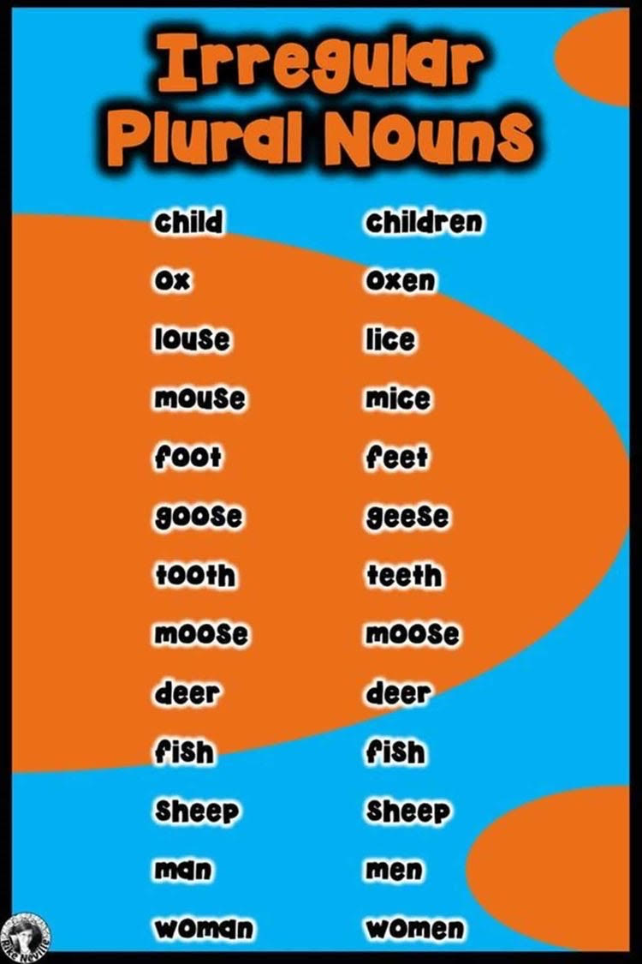

--------------------------------------

Now I want you to do these nouns:

פحل هذه الكلمات بحسب القائمة اعلاه

|  |  |
| --- | --- |
| singular | plural |
| man |  |
| ox |  |
|  | sheep |
| foot |  |
| Woman |  |
|  | children |
| mouse |  |
| Fish |  |
| Goose |  |
|  | Lice |