**وِحْدة تَعْليميّة لحرف ذ**

**يا مُنْذِر ماذا تَرى ؟**

**إنّي أرى الذُّبابَ .**

**يا مُنْذِر ماذا تَرى ؟**

**إنّي أرى الذُّئبَ .**

**_____________________________________**

**-ضَع دائِرَة حَوْلَ حرف ذ**

|  |
| --- |
| **ذِئْبٌ لَذيذ ذَهَبَ ذُباب مُنْذِر ذَيْل** |

**حَلّل الْكَلِمات إلى حُروف:**

**مُنْذِر __ __ __ __ أرى__ __ __ الذُّبابَ __ __ __ __ __ __ __ ماذا __ __ __**

**تَرى __ __ __ إنّي__ __ __ __**

**===================================**

**حَلّل الْكَلِمات إلى مَقاطِع :**

**مُنْذِر __ __ أرى__ __ الذُّبابَ __ __ __ __ ماذا __ __**

**تَرى __ __ إنّي__ __**

**++++++++++++++++++++++++++++++++++++**

**اكتب د أو ذ**

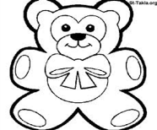  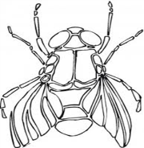 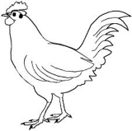

[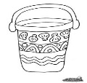](http://www.google.co.il/imgres?q=bucket+coloring+page&um=1&hl=iw&biw=1441&bih=657&tbm=isch&tbnid=igRCL-K-snSZ4M:&imgrefurl=http://yourbedtimestory.com/coloring_page.php?p=Bucket&docid=yrGuqXAiB2ESWM&imgurl=http://yourbedtimestory.com/img/pages/Bucket.jpg&w=794&h=1054&ei=rYBrT_6SOsqo0QXz9cXpBg&zoom=1)**____ ____ ____**

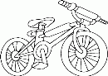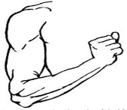 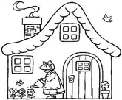

**____ ___ ___ __**

**أضف ال التعْريف:**

**دَرّاجَة --------**

**ذِراع --------**

**رَكَب الحروف لتحصل على كلمة مفيدة**

**ذِ ر ا ع مُ نْ ذِ ر بُ ذ و ر**

**_____ _____ ______**

**ذُ ب ا بَ ة لَ ذ ي ذ حِ ذ ا ء**

**_____ _____ ____**

**====================================**

**لون حرف الذال )ذ , ـذ )**

[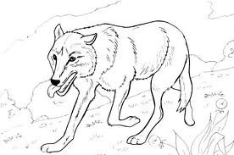](http://www.google.co.il/imgres?q=wolf+coloring+pages&um=1&hl=iw&biw=1441&bih=657&tbm=isch&tbnid=v-irFCcY3GfugM:&imgrefurl=http://www.tiptopglobe.com/free-coloring-pages-animals-fox-wolf&docid=A7TR1a5HDENxZM&imgurl=http://www.tiptopglobe.com/skin/omalovanky/nahled/zvirata-liska-vlk/c1a34517d6639892116c51dcdb65412d.jpg&w=453&h=300&ei=2UxrT4T3HdGT0QXKwsjKBg&zoom=1)[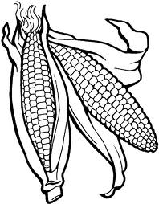](http://www.google.co.il/imgres?q=%D8%B5%D9%88%D8%B1%D8%A9+%D8%B0%D8%B1%D8%A9+%D9%84%D9%84%D8%AA%D9%84%D9%88%D9%8A%D9%86&um=1&hl=iw&sa=N&biw=1441&bih=657&tbm=isch&tbnid=JKjjMm3n5uxNkM:&imgrefurl=http://www.swar.info/2010/11/vegetables-coloring.html&docid=nOBkEHNXy_VBUM&imgurl=http://www.freecoloringprintable.com/img/vegetables-04.gif&w=541&h=692&ei=aUtrT_nSM4XL0QXzleXdBg&zoom=1)****

التاريخ :------------

**اكتب حرف الذال)ذ ـذ )**



[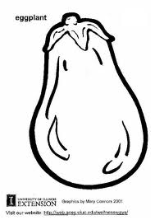](http://www.google.co.il/imgres?q=Eggplant+coloring&um=1&hl=iw&biw=1441&bih=657&tbm=isch&tbnid=rga6paeEMqGAhM:&imgrefurl=http://www.edupics.com/coloring-page-eggplant-i5802.html&docid=XYAX_wDTLVBm_M&imgurl=http://www.edupics.com/coloring-page-eggplant-dl5802.jpg&w=620&h=875&ei=SkxrT8qbH4Gp0QWb45DoBg&zoom=1)

---- رَة

---- ئب

با-- نْجان

[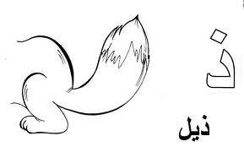](http://www.google.co.il/imgres?q=%D8%B0%D9%8A%D9%84+%D9%84%D9%84%D8%AA%D9%84%D9%88%D9%8A%D9%86&um=1&hl=iw&biw=1441&bih=657&tbm=isch&tbnid=JLEbRuCDVaqL3M:&imgrefurl=http://www.bordain.com/forums/index.php?topic=1820.0&docid=sef4zsShVf_ZdM&imgurl=http://www.bordain.com/tmp/moe/Picture5075.jpg&w=740&h=447&ei=701rT6SWF86T0QWMrY3RBg&zoom=1)[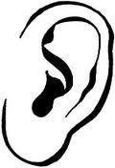](http://www.google.co.il/imgres?q=%D8%A3%D9%8F%D8%B0%D9%86+%D9%84%D9%84%D8%AA%D9%84%D9%88%D9%8A%D9%86&um=1&hl=iw&biw=1441&bih=657&tbm=isch&tbnid=_OiFLEISXB1myM:&imgrefurl=http://www.kids-n-fun.com/coloringpages/kleurplaat_Human-body_243.aspx&docid=BeIk27jdCo2SaM&imgurl=http://www.kids-n-fun.com/kleurplaten/lichaam/thumbs/lichaam_14.jpg&w=150&h=220&ei=Pk1rT9PAKcG_0QXS9cjdBg&zoom=1)[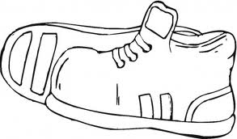](http://www.google.co.il/imgres?q=shoe+coloring+page&um=1&hl=iw&biw=1441&bih=657&tbm=isch&tbnid=NG1mQbYXd-2S1M:&imgrefurl=http://www.supercoloring.com/pages/sport-shoes/&docid=Bgqi4dWqFGBkIM&imgurl=http://www.supercoloring.com/wp-content/main/2009_05/sport-shoes-coloring-page.jpg&w=465&h=273&ei=uE1rT76WHIWx0QWwhKW4Bg&zoom=1)

צ

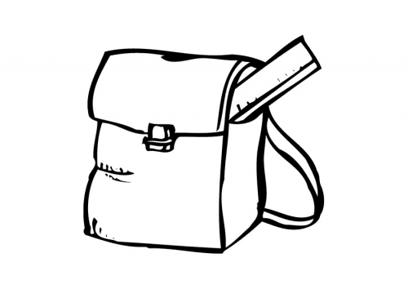

--- يْل

أُ---- ن

حِـ---- اء

[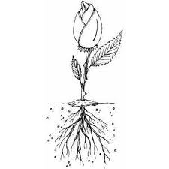](http://www.google.co.il/imgres?um=1&hl=iw&biw=1280&bih=763&tbm=isch&tbnid=M_mJqFlpqE9KdM:&imgrefurl=http://www.freeprintablecoloringpages.net/showcover/Plants_And_Flowers/Flower_With_Root&docid=0q53MXf-LUL-IM&imgurl=http://cdn.freeprintablecoloringpages.net/samples/Plants_And_Flowers/Flower_With_Root.png&w=300&h=300&ei=z1hrT7vSJMav0QWNtoHoBg&zoom=1)[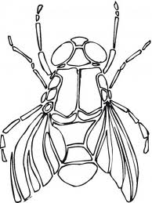](http://www.google.co.il/imgres?q=%D8%B0%D9%8F%D8%A8%D8%A7%D8%A8%D8%A9+%D9%84%D9%84%D8%AA%D9%84%D9%88%D9%8A%D9%86&um=1&hl=iw&biw=1441&bih=657&tbm=isch&tbnid=2A_WZPUq-Z0D3M:&imgrefurl=http://www.supercoloring.com/pages/category/insects/flies/&docid=DVMEBS5avXGbfM&imgurl=http://www.supercoloring.com/wp-content/thumbnail/2009_01/fly-6-coloring-page.gif&w=270&h=360&ei=r1BrT9yDMsrP0QXFvNS-Bg&zoom=1)[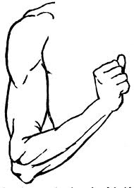](http://www.google.co.il/imgres?q=arm+coloring+page&um=1&hl=iw&biw=1441&bih=657&tbm=isch&tbnid=Ic9r90lMvFS-IM:&imgrefurl=http://ed101.bu.edu/StudentDoc/current/ED101sp09/jkouaya/ActWordStudy.html&docid=t25QWwfMb1KOqM&imgurl=http://ed101.bu.edu/StudentDoc/current/ED101sp09/jkouaya/word-arm.jpg&w=500&h=700&ei=aFBrT4blEMmq0QXRhaznBg&zoom=1)



---- راع

جُـ--- ور

ثَـ----لَب

----ـصْفور

---- بابَة