.

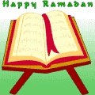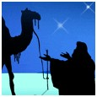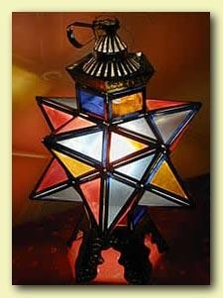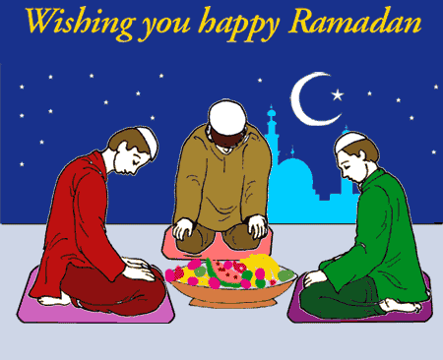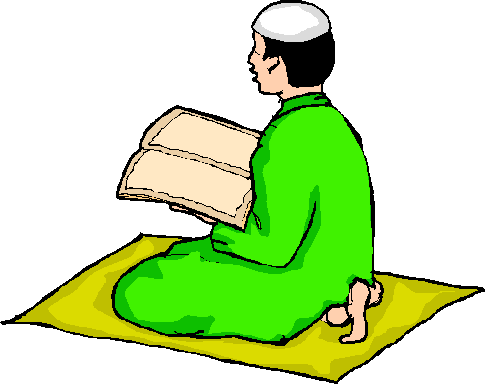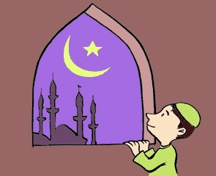



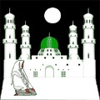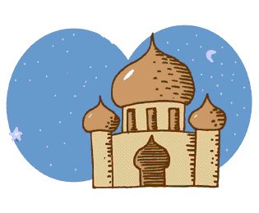

**A Ramadan Dictionary**

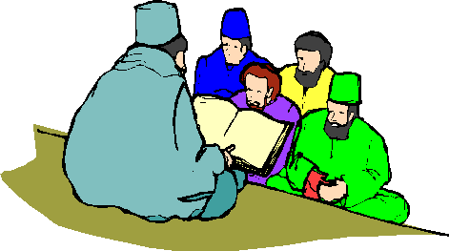

**Let’s learn some special Ramadan words in English!**

Angel

bless

break the fast

celebrate / celebration charity

colored

dates

daylight

devotion

fast

festival

generosity

give thanks

good deeds

اقرا النص ثم جد الكلمات

Read then find the words

Ramadan is the ninth month of the Islamic calendar. It is a ‘month of blessing’ – when the first words of the holy book, the Koran, were received.

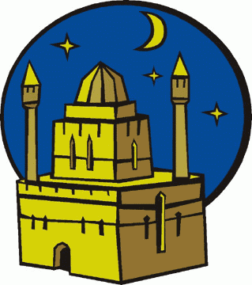

end

book

busy

thanks

Ramadan is a time of prayer, fasting and charity. It is also a time for self-sacrifice and devotion to Allah (God).

At many mosques during Ramadan, about one thirtieth of the Koran is read each night in prayers called *taraweeh*. This way, by the

end of the month, all of the Koran has been read.

During Ramadan, there is a festival-type atmosphere after sunset. In many cities, Moslems go out after they have broken the fast to visit family and friends or to simply take a walk.



night

deeds

broken

Shopping areas and restaurants are open and

busy.

Charity and good deeds are especially important at the end of Ramadan. At this time, Moslems are expected to show their generosity and

poor

fasting

month

Thanks by feeding the poor and giving money to

the mosques.

answer the following questions:

1- what is Ramadan?

2- what happening during Ramadan?

3- what so special about Ramadan?

4- what Muslims do after sunset?

5- continue the following sentences:

a- it is a month of prayers -----------------------------------.

b- at many cities, Muslims -----------------------------------.

6- choose the correct answer:

a- Ramadan is the __________ month?

1-first

2-ninth

3-tenth