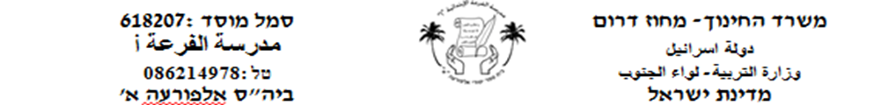

**קִרְאוּ אֶת האותיות اقرأوا الأحرف**

י

ו

ד

**כִּתְבוּ אֶת האותיות اكتبوا الأحرف**

ה

ב

בּ+ּ

א

**________________________________**

**________________________________**

**________________________________**

**________________________________**

**________________________________**

**________________________________**

**________________________________**

**________________________________**

**________________________________**

**________________________________**

**________________________________**

**________________________________**

**________________________________**

**________________________________**

**________________________________**

**________________________________**

**________________________________**

**________________________________**

**________________________________**

**________________________________**

**________________________________**

**________________________________**

**________________________________**

**________________________________**

**________________________________**

**________________________________**

**________________________________**

**________________________________**

**________________________________**

**________________________________**

**________________________________**

**________________________________**

**________________________________**

**________________________________**

**________________________________**

**________________________________**

**________________________________**

**________________________________**

**________________________________**

**________________________________**

**________________________________**

**________________________________**

ת

ר

מ

ל

ט

**________________________________**

**________________________________**

**________________________________**

**________________________________**

**________________________________**

**________________________________**

**________________________________**

**________________________________**

**________________________________**

**________________________________**

**________________________________**

**________________________________**

**________________________________**

**________________________________**

**________________________________**

**________________________________**

**________________________________**

**________________________________**

**________________________________**

**________________________________**

**________________________________**

**________________________________**

**________________________________**

**________________________________**

**________________________________**

**________________________________**

**________________________________**

**________________________________**

**________________________________**

**________________________________**

**עֲבוֹדָה יָפָה**