**בית ספר אלפורעה א –אלפורעה**

**טֶקְסט "אַבָּא קָנָה קַלְמָר"**

**שֵׁם תַלְמִיד:___________ כיתָה:__________**

**אַבָּא קָנָה קַלְמָר לְנָבִּיל**

**בַּקַלְמָר שֶׁל נָבִּיל יֵשׁ עִפָּרוֹן**

**בַּקַלְמָר שֶׁל נָבִּיל יֵשׁ עֵט**

**בַּקַלְמָר שֶׁל נָבִּיל יֵשׁ צְבָעִים**

**בַּקַלְמָר שֶׁל נָבִּיל יֵשׁ מַחַק**

**בַּקַלְמָר שֶׁל נָבִּיל יֵשׁ מְחַדֵד**

**בַּקַלְמָר שֶׁל נָבִּיל יֵשׁ סַרְגֵל**

**בַּקַלְמָר שֶׁל נָבִּיל יֵשׁ מִסְפָּרַיִם**

**בַּקַלְמָר שֶׁל נָבִּיל יֵשׁ דֶבֶק**

**הַקַלְמָר שֶׁל נָבִּיל נָפַל**

1. **כִּתְבוּ אֶת המילָה המתְאִימָה(اكتبوا الكلمة الملائمة):**

[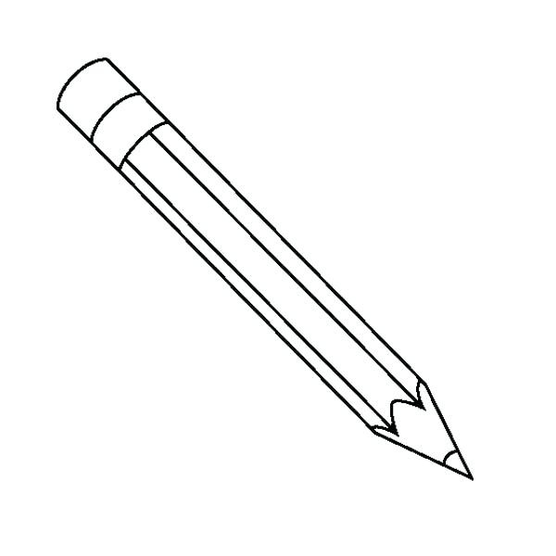](http://www.google.co.il/url?sa=i&rct=j&q=&esrc=s&source=images&cd=&cad=rja&uact=8&ved=2ahUKEwiA6M7_25niAhXFKVAKHbb7AYoQjRx6BAgBEAU&url=http://www.amisvegetarian.com/pencil-clipart-black-and-white-wedding-clipart/pencil-clipart-black-and-white-pencil-clipart-black-and-white-printable-and-formats-science-clipart/&psig=AOvVaw3GQAZonA7FqqD-rQXHmzgw&ust=1557878551209508)**(צְבָעִים, קַלְמָר, מוּנִירָה, אַבָּא, נַבִּיל, עִפָּרוֹן, מִשְׁקָפַיִם, חֲתוּלָה)**

[](https://www.google.co.il/url?sa=i&rct=j&q=&esrc=s&source=images&cd=&cad=rja&uact=8&ved=2ahUKEwijw46k25niAhXRZVAKHcVnAXoQjRx6BAgBEAU&url=https://www.sharefaith.com/image/son-on-fathers-shoulders-in-black-and-white.html&psig=AOvVaw3xQHPOM_aSi82rv9naMEiW&ust=1557878360176140)

[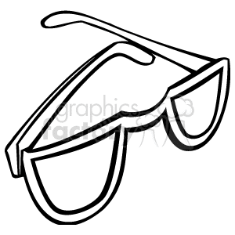](https://www.google.co.il/url?sa=i&rct=j&q=&esrc=s&source=images&cd=&cad=rja&uact=8&ved=2ahUKEwjEoZKl3JniAhVPY1AKHa8nCS4QjRx6BAgBEAU&url=https://www.graphicsfactory.com/Clip-Art/People/Kids/hldn021-bw-159163.html&psig=AOvVaw0Iy-ekzyng5fyqFeo8jQ7C&ust=1557878627611036)

[](http://www.google.co.il/url?sa=i&rct=j&q=&esrc=s&source=images&cd=&ved=2ahUKEwiL6Zj13ZniAhUJa1AKHaP-D6IQjRx6BAgBEAU&url=http://clipartmag.com/black-and-white-clipart-boy&psig=AOvVaw2Exfb1TP3VlOSQiqF3sCmB&ust=1557879021920706)

[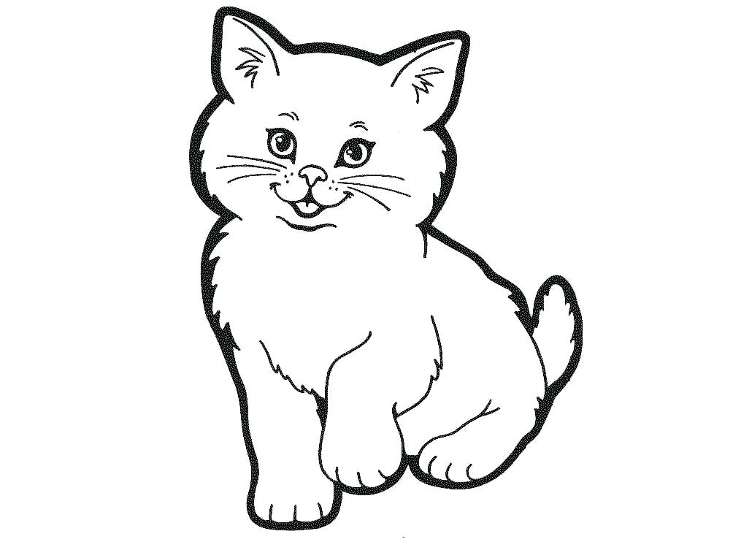](https://www.google.co.il/url?sa=i&rct=j&q=&esrc=s&source=images&cd=&cad=rja&uact=8&ved=2ahUKEwjNrd7_3JniAhWDK1AKHTDwANQQjRx6BAgBEAU&url=https://download-free-clip.art/black-and-white-clip-art-cat/black-and-white-clip-art-cat-black-cat-drawing-images-11/&psig=AOvVaw0mRY1-efIoV5rPlJ_f4Mcr&ust=1557878806274296)

[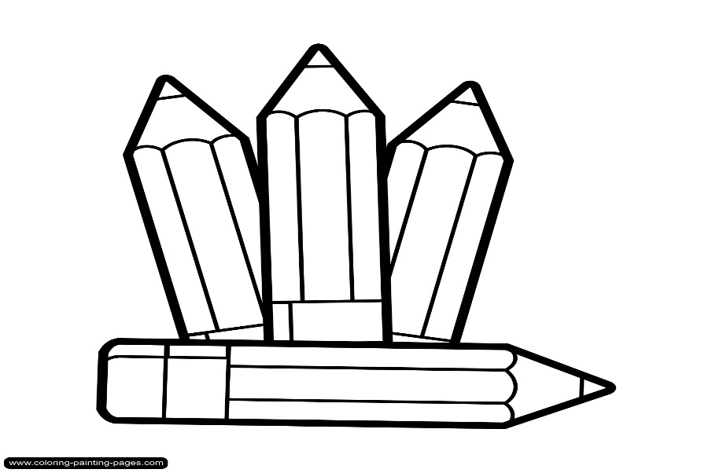](http://www.google.co.il/url?sa=i&rct=j&q=&esrc=s&source=images&cd=&cad=rja&uact=8&ved=2ahUKEwir4-7D3JniAhWGaVAKHT13A6UQjRx6BAgBEAU&url=http://gclipart.com/pencil-clipart-black-and-white_33642/&psig=AOvVaw2J8aguyrJwXxlJSGHB_RS2&ust=1557878680474135)

1. **פּרְקו אֶת המילים להברוֹת (حللوا الكلمات إلى مقاطع):**

קַלְמָר: חֲבָל:

אַבָּא: מוּנִירָה:

קָנָה: צָחֲקָה:

בַּקַלְמָר: רָאֲתָה:

יֵשׁ:

עִפָּרוֹן:

הַקַלְמָר:

מִשְׁקָפַיִם:

1. **צבעו אוֹ הַקִיפו אֶת מָה שֶׁיֵשׁ בַּקַלְמָר של נביל לפי הטקסט:**

[](http://www.google.co.il/url?sa=i&rct=j&q=&esrc=s&source=images&cd=&cad=rja&uact=8&ved=2ahUKEwiA6M7_25niAhXFKVAKHbb7AYoQjRx6BAgBEAU&url=http://www.amisvegetarian.com/pencil-clipart-black-and-white-wedding-clipart/pencil-clipart-black-and-white-pencil-clipart-black-and-white-printable-and-formats-science-clipart/&psig=AOvVaw3GQAZonA7FqqD-rQXHmzgw&ust=1557878551209508)[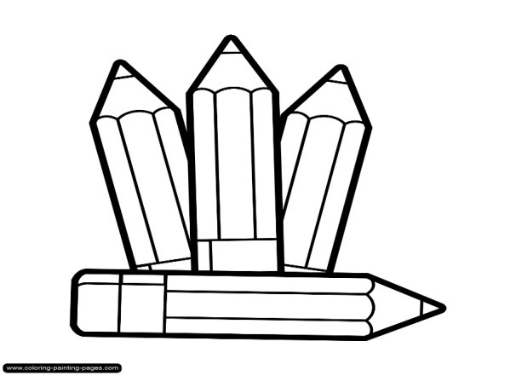](http://www.google.co.il/url?sa=i&rct=j&q=&esrc=s&source=images&cd=&cad=rja&uact=8&ved=2ahUKEwir4-7D3JniAhWGaVAKHT13A6UQjRx6BAgBEAU&url=http://gclipart.com/pencil-clipart-black-and-white_33642/&psig=AOvVaw2J8aguyrJwXxlJSGHB_RS2&ust=1557878680474135)[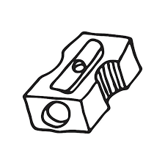](https://www.google.co.il/url?sa=i&rct=j&q=&esrc=s&source=images&cd=&cad=rja&uact=8&ved=2ahUKEwirnZ6v4ZniAhXCbVAKHZt3BuMQjRx6BAgBEAU&url=https://www.clipart.email/clipart/pencil-sharpener-clipart-black-and-white-12286.html&psig=AOvVaw0zOodw9zVFopeNeSzlM_1U&ust=1557879989415808) **(لَوّنوا أو أحيطوا فقط ما يوجد في مقلمة نبيل حسب النص):**

[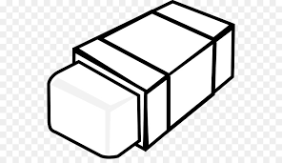](http://www.google.co.il/url?sa=i&rct=j&q=&esrc=s&source=images&cd=&cad=rja&uact=8&ved=2ahUKEwjEibrX4ZniAhUEElAKHVtZAVoQjRx6BAgBEAU&url=http://thebloodofjesus.info/pencil-top-eraser-clipart-black-and-white/&psig=AOvVaw1XCN7ObGL3jSxQJAmCgMfF&ust=1557880074262682)[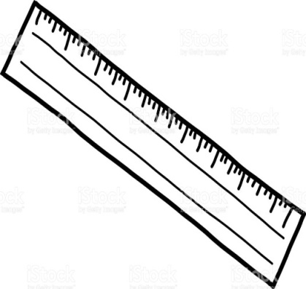](https://www.google.co.il/url?sa=i&rct=j&q=&esrc=s&source=images&cd=&cad=rja&uact=8&ved=2ahUKEwiDrPX64ZniAhVGYVAKHXWeCHUQjRx6BAgBEAU&url=https://mastergolflivestream.com/image/clipart-ruler-sketch/241374.html&psig=AOvVaw1NeHafVV4rYj1schD2Vxt7&ust=1557880152636770)[](https://www.google.co.il/url?sa=i&rct=j&q=&esrc=s&source=images&cd=&cad=rja&uact=8&ved=2ahUKEwjEoZKl3JniAhVPY1AKHa8nCS4QjRx6BAgBEAU&url=https://www.graphicsfactory.com/Clip-Art/People/Kids/hldn021-bw-159163.html&psig=AOvVaw0Iy-ekzyng5fyqFeo8jQ7C&ust=1557878627611036)