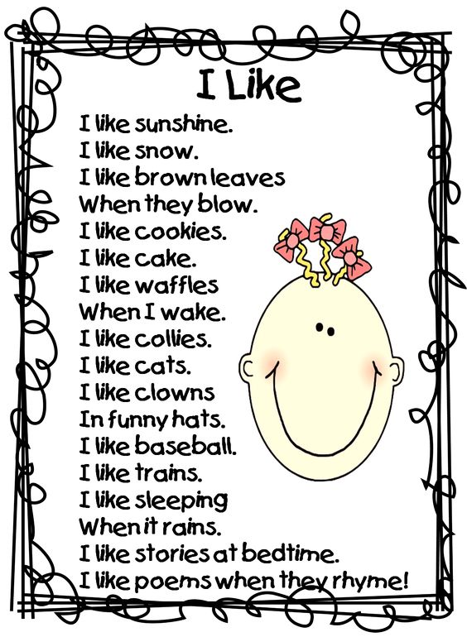

***Read the poem and write*** **انا احب**

1. The writer likes many things; write two things he likes to eat: ___________________________________________________________
2. Write two things he likes to do.

___________________________________________________________

1. Write the rhymes from the poem

___________________________________________________________

1. Write things you like.

___________________________________________________________